The Morlet Wavelet Transform. At the outset, I wish to state that before I started this project, I was totally ignorant of the subject of wavelets and their use. Although I seemed to have learned enough to develop a successful wavelet transform software package for the dissection of recorded organ pipe sounds, I am still in no way an expert in this area. I spent many hours of agony trying to recreate the logic imbedded in the software implementation to provide the following explanation.

Specifically, I have used the Morlet wavelet, which is basically a sinusoidal probe bounded inside a Gaussian envelope. Other wavelet tools exist that use other forms of probing signal inside the envelope. I specifically chose a sinusoidal probe because I wish to analyze the components of the organ pipe waveform which are essentially discrete sinusoids with imposed amplitude modulation. I use the Morlet wavelet transformation as a tunable narrowband filter, which maps out the amplitude envelope and phase for each frequency component in the sound that I’m analyzing.

A good introduction to Wavelet Analysis can be found online at
http://atoc.colorado.edu/research/wavelets/wavelet2.html

The specific wavelet transform expression used in my development was drawn from equations 2.1 and 2.2 in the reference cited above. The basic expression for the Morlet wavelet given in (2.1) is
1) Ψo(n) = π^{-1/4} *e ^{i ωo n} * e ^{– n * n / 2}

where n is a time variable, and ωo = 2 * π * fo, where fo is the frequency of the probing sinusoid. As stated in the reference above, “this is the basic wavelet function, but we now need some way to change the overall size as well as slide the entire wavelet along in time. Thus we define the ‘scaled wavelets’ as:”

2) Ψ[(n’-n) dt /s] = (dt / s)^{1/2} * Ψo[(n’-n ) dt /s]

Where here “n” and “n’” are dimensionless, “dt” is the increment in time between digital samples of the waveform, and “s” is a scaling parameter that is used to increase or decrease the number of cycles of probe signal inside the Gaussian envelope. If you strictly apply equation (2) to (1), you end up with the scaling parameter “s” occurring in both the probe signal e ^{i ωo n} and the Gaussian envelope e ^{– n*n / 2} , which I truly believe is not intended. The intent is to be able to vary the number of cycles of probe signal inside the Gaussian envelope, and this can only be done if the scaling parameter is inserted in the Gaussian envelope and not the probe. Hence, my implementation of (2) becomes (with the substitution of “m = n’ – n” for short-hand purposes)

3) Ψ[(m) dt /s] = (dt / s)^{1/2} * π^{-1/4} *e ^{i ωo m} * e ^{– m *m /(2 * s * s)}

In my implementation, I have chosen to express “s” as equal to M/(2 * π * fo), where I define “M” as a Morlet number. Note that this is my specific terminology and it does not apply to anyone else’s implementation. This terminology tracks what is written in my software implementation. “M” is an approximate measure of the number of cycles of probe contained inside the Gaussian envelope.

Note that “dt” is equal to the reciprocal of the sample rate S. Also, in my software code I define “w” to be equal to 2 * π / S. Making the substitutions for “s” and “dt” and noting that ωo = 2 * π * fo , equation (3) can be rewritten as

4) Ψ[(m) dt /s] = (w * fo/ M)^{1/2} * π^{-1/4} * e ^{i w*fo *m} * e ^{– 0.5*(w*fo*m)* (w*fo*m)/(M}*^{M )}

where the expression (w*fo*m) is repeated in the exponent to indicate that the quantity is squared. (I can’t successfully write superscripts on top of superscripts to denote a squared superscript in MS Word!). At this point it is very instructive to look at some plots of the function

5) F(m,fo,M) = e ^{i w*fo*m} * e ^{– 0.5*(w*fo*m)* (w*fo*m)/(M}*^{M )}

In the first chart below we substitute cos( w*fo*m) for e ^{i w*fo*m} to stay in the real (vs complex) space and we held M constant at a value of 5.0 and show what happens to the waveform as we change frequency over the (100, 500, 1000 Hz) set of values.

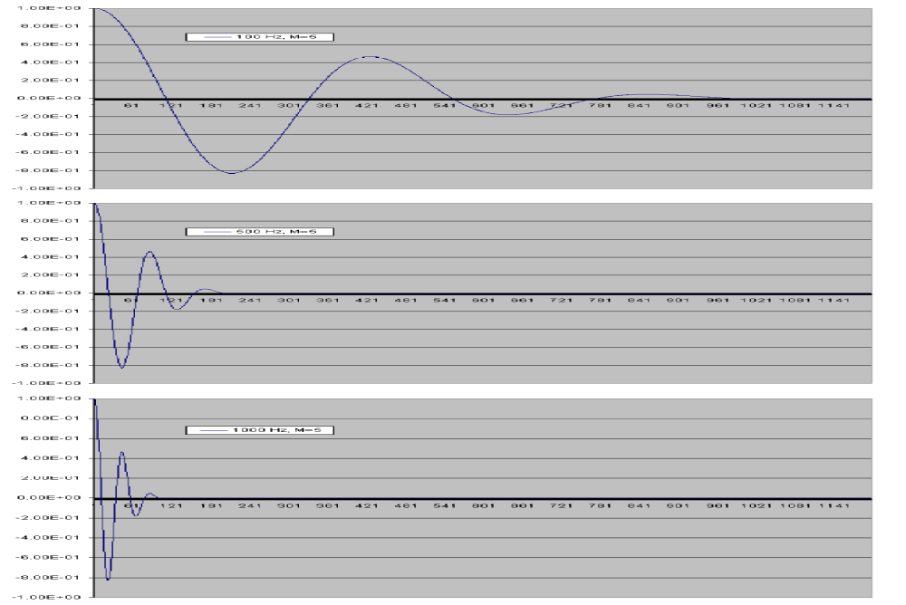

From this chart we can verify the assertion that the number of cycles of the probe signal inside the Gaussian envelope is approximately equal to M on the scale shown if we count the (un-shown) negative side of the time axis as well as the positive side. It is also obvious that if we hold M constant and increase frequency, the envelope width diminishes. We will show later on that the wavelet transform has the best impulse response when M is kept small, say about equal to 5.0. However, at higher frequencies we find that the transform coefficients become oscillatory at this small a value for M. Higher values of M avoid the oscillations but make the impulse response poorer. A reasonable compromise seems to be to make the chosen value of M to depend on frequency as

M = 5.0 * SQRT(fo/100.0)

With this choice of M, the wavelet function then changes with frequency as shown in the next chart.
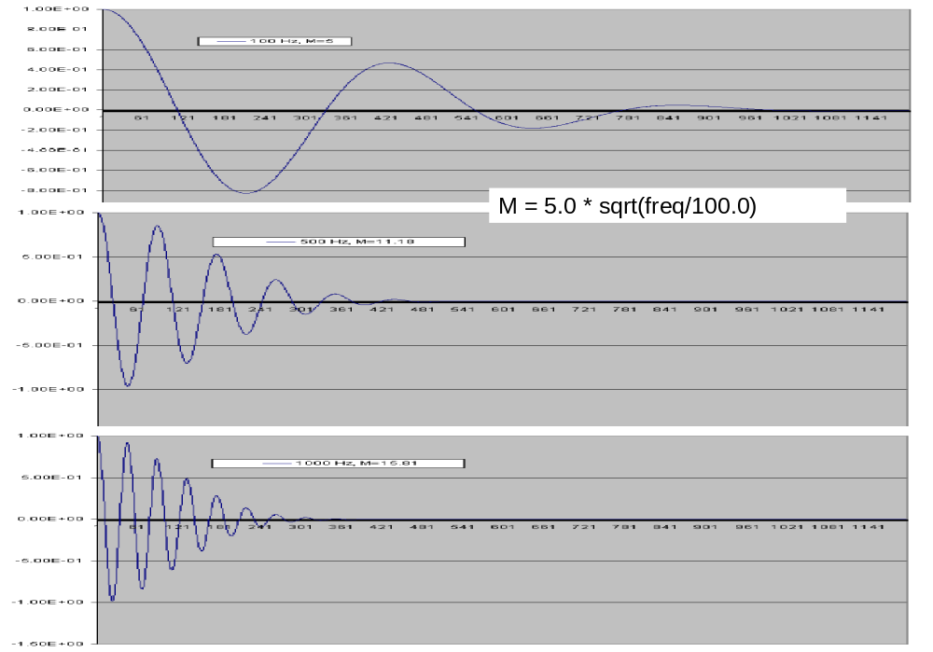

In this case the width of the envelope decreases more slowly with frequency. We could keep the envelope width independent of frequency if M was made to be dependent on fo/fref, where fref is an arbitrary reference frequency. I don’t do that because it leads to poor impulse response.

Suppose that we have a waveform that we wish to analyze, which we call “X(n)”.
We wish to use equation (4) to calculate the complex Morlet wavelet transform coefficients for “X(n)”. Since this will require summations involving “n-n’” (shorthanded as “m”), we will focus at present only on the exponential part of equation (4), which is equation (5). We will come back later and pick up the remaining parts of equation (5). The transform requires that we slide the analysis window across each data point in X(n). Having done this we calculate new transform coefficients for each point “n” in X(n). Hence,

6) TX(n) =Σ_{n-Δ}^{n+Δ} X(n) * e ^{i w*fo*(n’-n)} * e – 0.5*(w*fo*{m’-n})* (w*fo*{n’-n})/(M*^{M )}

where the summation is over n’ = (n-Δ,n+Δ), where Δ is sufficiently far from the center of the Gaussian to result in negligible error for not continuing the summation further. I have found that setting Δ = 500 results in negligible error and it is hard-coded into the Morlet_probe program. Next I break out equation (6) into real and imaginary parts:

7a) Real[TX(n)] =Σ_{n-Δ}^{n+Δ} X(n) * cos( w*fo*(n’-n)) * e – 0.5*(w*fo*{m’-n})* (w*fo*{n’-n})/(M*^{M )}

7b) Im[TX(n)] =Σ_{n-Δ}^{n+Δ} X(n) * sin( w*fo*(n’-n)) * e – 0.5*(w*fo*{m’-n})* (w*fo*{n’-n})/(M*^{M )}
Rather than work with these complex coefficients, I prefer to convert them into magnitude (or amplitude) and phase. Then,

8a) A_{o}(n) = SQRT(Real[TX(n)] * Real[TX(n)] + Im[TX(n)]*Im[TX(n)]) and

8b) P(n) = (180/pi) * arctan(Im[TX(n)]/Real[TX(n)])

Where A(n) is proportional to the amplitude envelope for the particular probe frequency that was used and P(n) is the phase angle in degrees associated with each transform point “n” for the probe frequency used. Note that this process is repeated anew for each different probing frequency. Note that the factor (w * fo/ M)^{1/2} * π^{-1/4} in equation (4) that we have neglected so far, does not affect equation (8b) since the ratio of Im[TX(n)]/Real[TX(n)] cancels it. On the other hand the true transform amplitude envelope “should be” equal to

9) A(n) = norm * (w * fo/ M)^{1/2} * π^{-1/4} * A_{o}(n)

Where norm is a normalization factor that is required so that A(n) is equal to 1.0 if a continuous sin or cosine wave of any frequency is analyzed with an equal probing frequency. However, I have determined that the correct normalization is
- A(n) = (1.1368E-4) * (fo/ M) * A_{o}(n)

where I have absorbed the “w” and “π” factors in the numerical constant. Note that the dependence is to the first power of (fo/ M) and not the square root. This dependence was determined by using the non-normalized computer program to compute the envelope magnitude for constant-amplitude test waveforms that were generated for different frequencies. The digital waveforms were generated using an Excel spreadsheet.

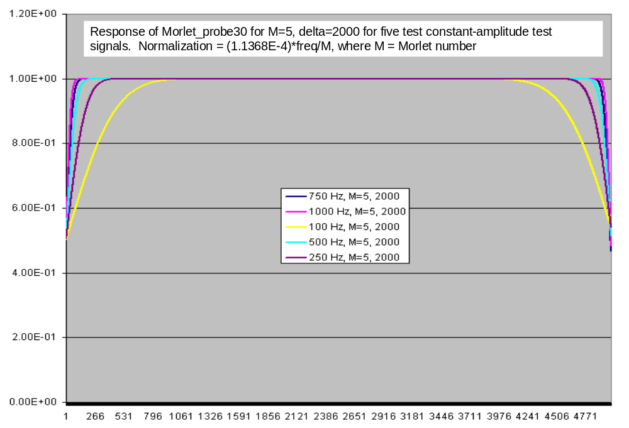

The chart above shows the result of the Morlet_probe computer program when normalized as stated above. The program was run for many test waves at different frequencies and analyzed at different values of M to determine and validate the normalization expression above. The difference in the dependence on the ratio of (fo/ M) between my validated expression and that derived from the reference material is either a misinterpretation on my part or an error in the reference equations.

In the chart above, the program was run for each unity-amplitude test signal at the five frequencies shown. The magnitude of the envelope of the recovered signal reached a value of 1.0 for each waveform analyzed. For plotting convenience, the annotations on the x-axis (abscissa) correspond to the sample index which increases by one for each new sample at a sample rate of 1/44,100. The complete span of 5000 points is equal to 0.113 seconds. The amount of time for each trace to reach the steady state value of 1.0 is a measure of the impulse response, which is the amount of time required to reach steady state after a step-change in the envelope amplitude of the test wave. The impulse response is naturally slower at the lower frequencies. At M=5.0, the impulse response at 1 kHz is under 3 msec.

The program was also tested against a single waveform that contained equal amounts of constant amplitude components at frequencies of 100, 250, 500, 750, and 1000 Hz.

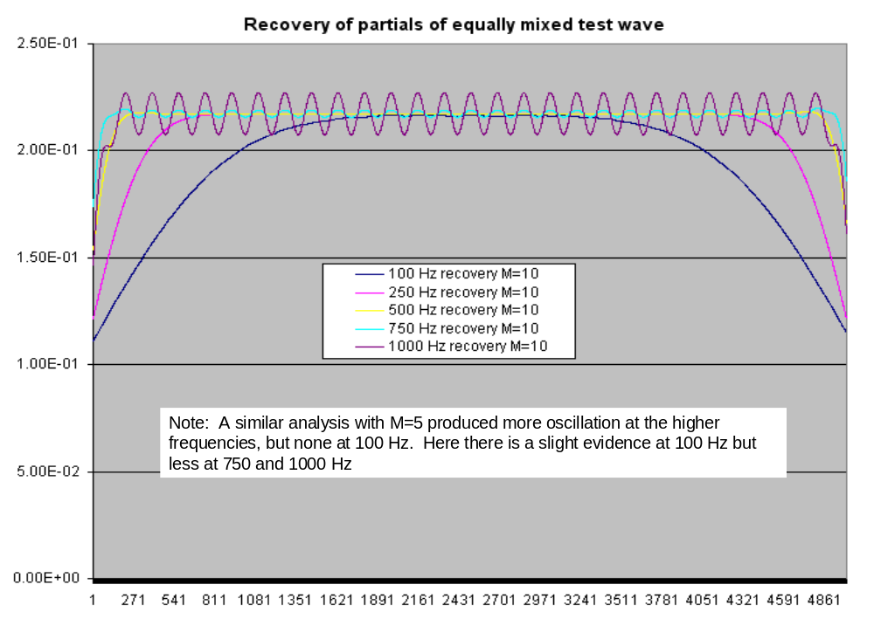

The results of this test for M=10 are shown above. Note that all recovered envelope magnitudes were essentially equal after steady state was achieved. However, the oscillatory behavior that I mentioned earlier is now evident for the 1 kHz recovered envelope. The oscillations were not present when only a single 1 k Hz test wave was used but are present when the waveform being tested is multi toned. The oscillation disappeared at 1 kHz when M was increased in value. One might expect that the recovered envelope magnitudes should be of value 1.0/5.0 = 0.20, rather than the slightly higher value of about 0.22 in the chart above. I think that discrepancy is caused by the fact that I introduced progressive phase offsets for each frequency component in the composite waveform. I did this to reduce the “crest factor” of the resultant wave, which is in effect modulated by the interaction of the various frequency components. Crest factor is defined as the ratio of the peak of the waveform to its rms value. If all frequency components are mixed together with zero phase offset, the crest factor will be maximum. I believe that the compression of the crest factor caused by introducing the phase offsets in the test wave is responsible for the envelope value of 0.22 instead of 0.20.

The same test was done when M was not held constant, but instead computed in the program as

M = 5.0 * SQRT(fo/100.0)

The result is shown below.

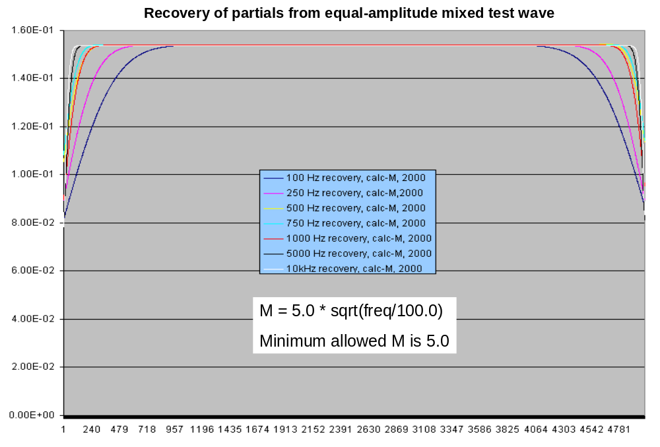

Here we added additional frequency components at 5.0 and 10.0 kHz to the composite test waveform. All envelopes were recovered at equal amplitude and there were no oscillations even at the highest frequency. Note that since the computed value of M at 100 Hz was 5.0 (lower than the 10.0 value on the previous chart) the impulse response has improved for this component.

Impulse measurements were made at 1 kHz for two different values of M. The test waveform is shown below with a 30% step increase in amplitude.
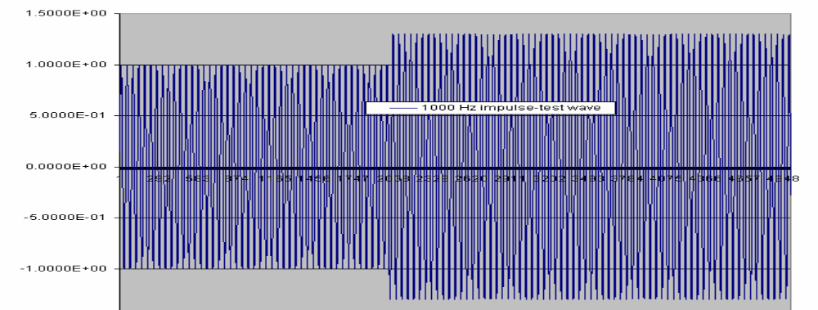

The result of the processing of this test waveform with Morlet_probe for M= 10 is shown below.

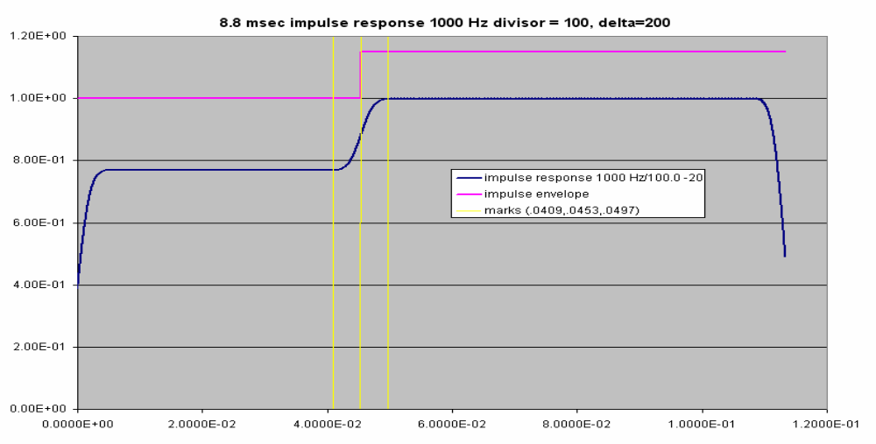

The abscissa scale is time in seconds. The amount of time bounded by the two outer yellow bars is 8.8 msec, which is actually somewhat larger than the impulse response. The corresponding impulse response for M= 55.55 is shown below.

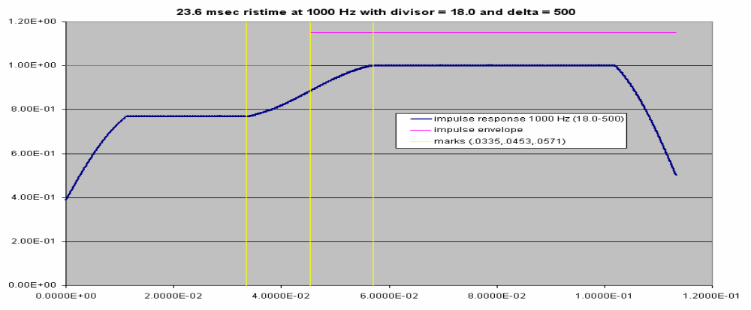

Here the impulse response is much poorer, suggesting that we will not want to set M= 55 for a frequency near 1 kHz. Note that for this example, M was calculated in an earlier program version as equal to fo/18.0 with no multiplier as used in earlier discussions.

The program was tested for frequency selectivity; i.e., its ability to recover the envelope of a partial of amplitude 0.25 that was close to another partial of amplitude 1.0. The first test was to imbed a 0.25 amplitude partial at 1.5 kHz in a mixed composite wave with frequencies (100,250,500,1k,5k, and 10kHz) and amplitudes of 1.0. The result is shown below.
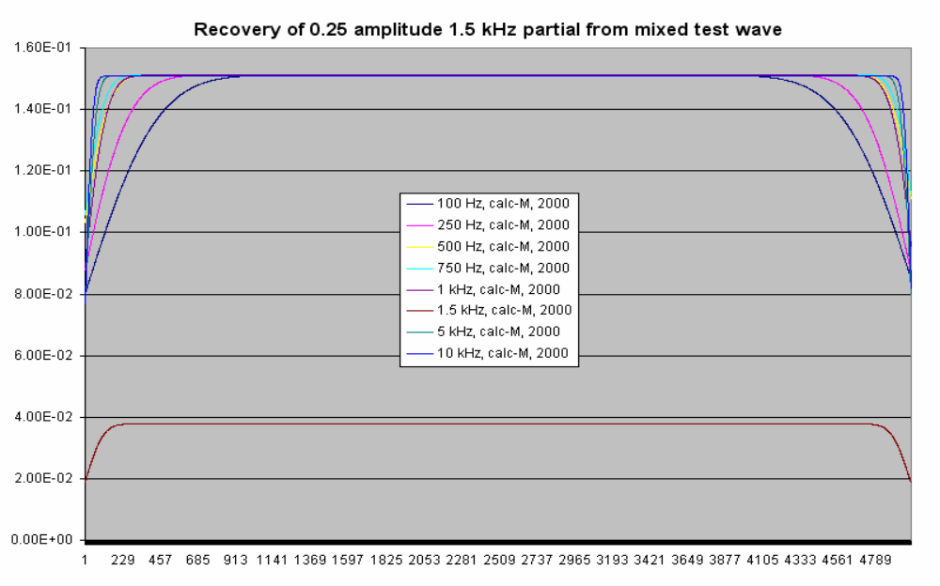

The result was excellent. The envelope of the 1.5 kHz partial was exactly 0.25 times smaller than the other envelope amplitudes. The next test was identical except that the frequency of the imbedded partial was 1.2 kHz. The result is shown below.
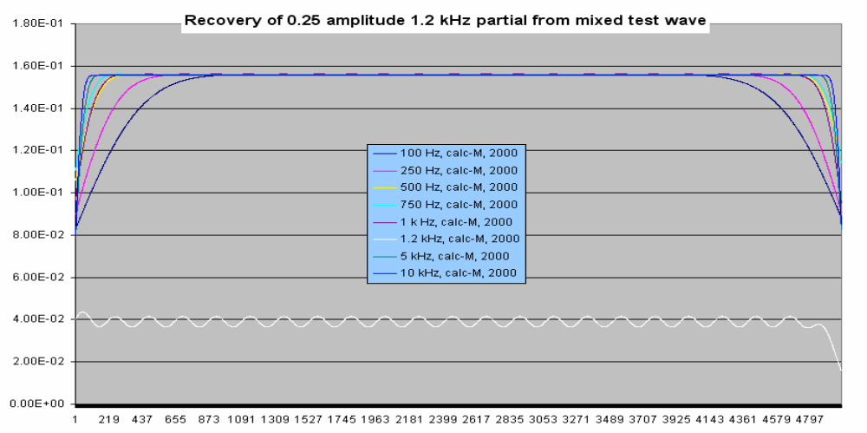

Again, the result was as expected except that we note that oscillation has begun to set in. We are near the breaking point. The next experiment placed the partial at 1.05 kHz (only 50 Hz away from the larger 1 kHz partial) and this is where failure sets in as seen below.
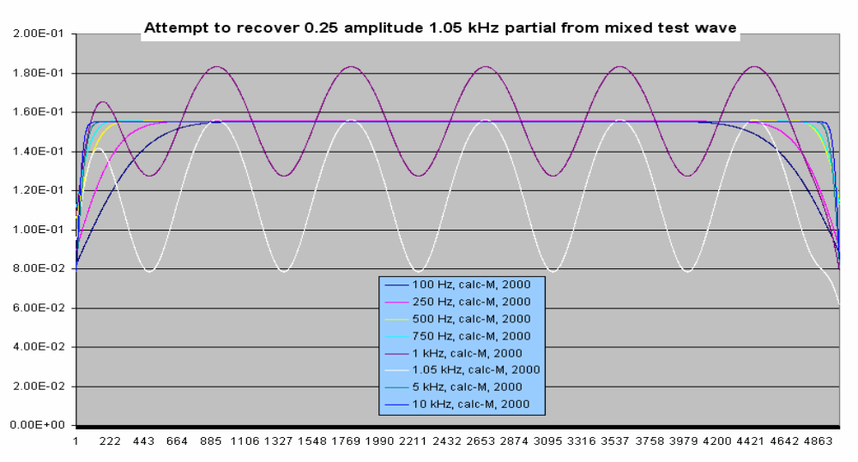

I have not investigated whether using a larger value of M would improve the frequency discrimination, but that might be an area for future study.

Digging more deeply, we look again at the 1.5 k Hz partial but this time its amplitude in the test wave is only 0.01 as large as the other partials or, equivalently, -40 dB in relative power.
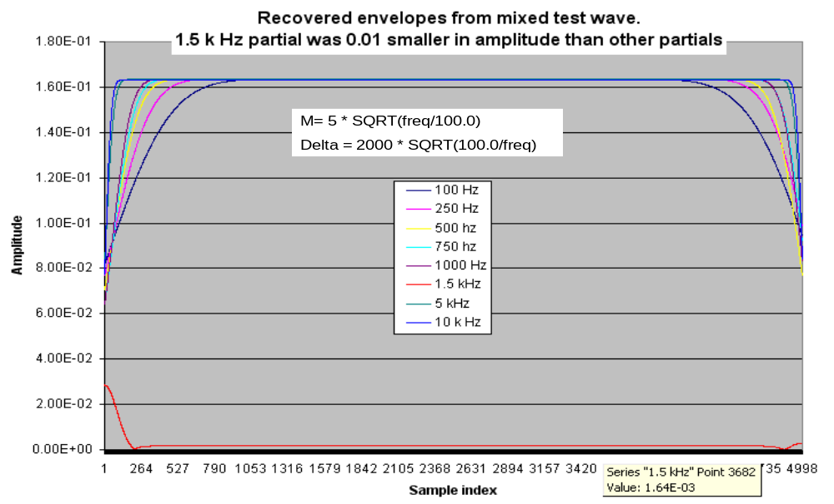

Again, Morlet_probe has recovered the envelope for the 1.5 kHz partial at a value of 1.64E-3, which is exactly 0.01 times the value of the envelope for the other partials. For this set of calculations the value of delta parameter was not held constant at 2000 as was the case for previous calculations. Instead, we let

delta = 2000 * SQRT(100.0/freq)

Where “freq” is the frequency of the partial being analyzed. By choosing delta in this way, the calculations are completed more rapidly at higher frequencies without loss of accuracy.

The last issue that I want to address is whether it is beneficial to front-load the sound file to be analyzed with 500 to 1000 zeros to get a cleaner start up. The previous data set was front-loaded with 1000 zeros and re-analyzed. The result is shown below.

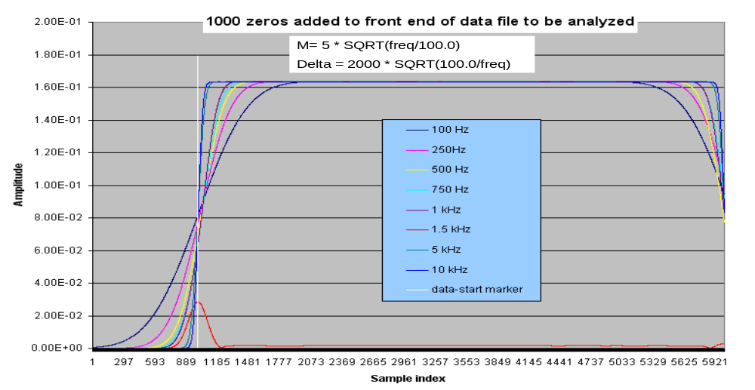

The white vertical line is drawn at data point 1000 beyond which the test-wave data begins. To the right of the white line, the data plots are identical to those in the previous figure, which was analyzed without any zero loading. Hence, there does not seem to be any value in zero-loading the front of the sound file to be analyzed.

The foregoing discussion provides good insight into the performance of Morlet_probe for recovering the envelope amplitudes. The remainder of the discussion will deal with phase recovery.

The phases were recovered for all partials in the mixed test wave consisting of equal additions of sine waves at frequencies of 100, 250, 500, 750, 1000, 5000, and 10,000 Hz. To each component in the test wave a different constant phase offset was added. The offset was calculated by the (arbitrary) expression

Phase_offset = (PI -1) * 12.0 degrees

Where PI is the partial index for each frequency component considering the 100 Hz to be the fundamental with a PI = 1. Hence the first partial (the fundamental) would have zero phase offset. The 250 Hz component would have a PI of 2.5. The raw phase output of Morlet_probe is as calculated from equation (8b). Actually the computer program uses the atan2 function which returns the angular argument between +π and –π radians or +,- 180 when converted to degrees. Hence the output is a discontinuous function of time as shown at 100 Hz in the figure below.

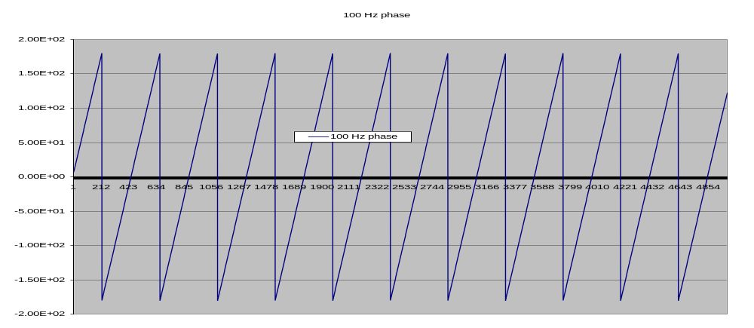

The discontinuities are removed by passing these data through my continuous_phase program, which detects each offset and adds 360 degrees to make the function continuous. The continuous phase data for the first five partials are shown in the following chart.

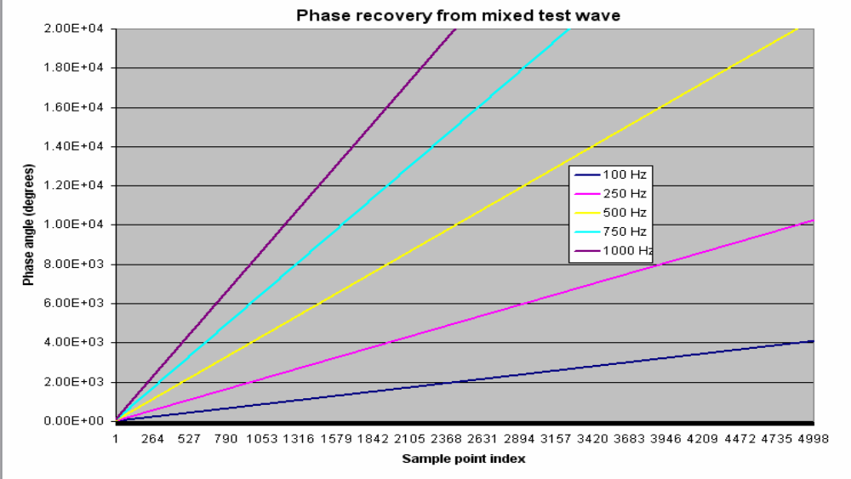

A closer look at the intercepts can be seen in the following chart which displays data for only the first 100 data points.

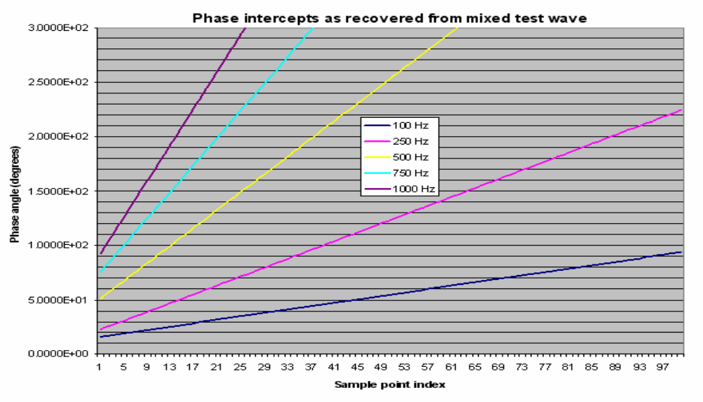

I wish to compare the phase intercepts, determined from the phase data output of Morlet_probe, with the known phase intercepts of the test wave. There are several ways this can be done. First, one could attempt to read the intercept from the abbreviated data plots above. Alternatively, one could simply look at the numerical value of the first point in the continuous-phase data for each partial. The latter approach provides a more precise value than can be read from the chart. Both of these methods, however, are essentially equivalent. A second, non-equivalent method is to ignore the first 999 data points because we know that in the case of the envelopes it takes some time for the wavelet transform to stabilize. Hence, I used Matlab to do a least-square-error fit to a linear equation for the phase data for points 1000 to 5000 . This equation was then used to predict the phase for each partial at the first data point. ( Note: I inadvertently generated the test wave starting at time 2.2676E-5 seconds [the first sampling increment] instead of time = 0.0 seconds. Hence the intercepts for the first data point are equal to the computed offset (PI-1) * 12.0 plus 2 * 180 * f * t degrees ).

 | Measured versus actual phase intercepts
 | actual intercept | measured intercept | measured intercept
Freq | (degrees) | (degrees) | (degrees)
(Hz) |  | method 1 | method 2
100 | 0.817 | 16.1 | 1.5338
250 | 20.04 | 22.8 | 18.5443
500 | 52.09 | 51.1 | 52.4923
750 | 84.13 | 75.4 | 83.5584
1000 | 116.16 | 92.6 | 118.2079
5000 | 628.8 or 268.8* | 278.4 | 268.8796
10000 | 1269.6 or 189.6* | 191.1 | 189.8673
method 1: value of first recovered-phase data point
method 2: via least-square-error fit to recovered phase data points [1000:5000]

The data above show the actual intercept at the first data point and the intercept measured by the two methods described above. As one might expect, the second method gives results that are quite close to the correct values while the first method has more error. The “*” in the chart above indicates the phase reduced to the lowest number modulo 360 degrees.

This concludes the discussion of the Morlet_probe wavelet transform program. A code listing for Morlet_probe and Continuous_Phase follows.

Morlet_Probe Program

/* Morlet_probe40 (currently the preferred code to use) */

/* Program modified 15 October 2007 to make delta frequency
dependent delta=deltao * sqrt(100.0/freq[k]);
intent is to speed up computation with no loss in accuracy */
/* Program modified 10 October 2007
The Morlet number "mn" is changed with frequency as
mn=5*sqrt(freq[k]/100.0) and the minimum value of mn is always 5.0
The normalization is...
norm = (1.1368E-4)*freq[k]/mn and this works well for
different mn and frequencies */

/* This program was developed and written independently in
September 2006 by
Edwin L. Althouse, elalthouse@comcast.net. */

#include <stdio.h>
#include <stdlib.h>
#include <string.h>
#include <math.h>

void Read_myconfig(char *fin);
void Read_frequencies(char *fin);
void Read_soundfile(char *fin);
void Write_output(char *fout);
void Read_logicals(void);
void Read_amplitude_names(void);
void Read_phase_names(void);

float pi = 3.14159271f;
float w,mf,norm,mn;
float freq[100],indata[62000],amp[62000], arg[62000];

double gauss,sum1,sum2,sum3,temp;

char amplitude_name[101][30],phase_name[101][30];
char filename1[]="myconfig.txt";
char filename2[]="soundfile.txt";
char filename3[]="logicals.txt";
char filename4[]="frequencies.txt";
char filename5[]="amplitude_names.txt";
char filename6[]="phase_names.txt";
char *fin, *fin2, *fout1, *fout2, *ptr5, *ptr6;

int logical[100],numpts,num_partials,mtemp;
int delta0,delta,ilow,ihigh, m,n,k,kk,j,i;

/* ----------------------------------------------------------------- */
/* Read_myconfig function definition */
void Read_myconfig(char *fin)
{
FILE *fptr1;
if ((fptr1 = fopen(fin, "r")) == NULL) {
printf("Cannot open myconfig.txt for reading.\n");
exit(1); }
else {
fscanf(fptr1,"%d",&numpts); /* total number of data points in the
soundfile being analyzed. */

fscanf(fptr1,"%d",&num_partials); /* total number of partials being analyzed and listed in the freq.txt file. */
fclose(fptr1);

printf("numpts = %d\n", numpts);
printf("nnum_partials = %d\n", num_partials);

}
}
/* ----------------------------------------------------------------------- */
/* Read_logicals function definition */
void Read_logicals(void)
{
fin=filename3;
FILE *fptr4;
int k;
if ((fptr4 = fopen(fin, "r")) == NULL) {
printf("Cannot open logicals.txt for reading.\n");
exit(4); }
else {

for(k=0;k<=num_partials-1;k++) fscanf(fptr4,"%d",&logical[k]);

fclose(fptr4);

printf("The partial logicals are:\n");
for (k=0;k<=num_partials-1; k++) printf("logical[%3d] = %d\n",k,logical[k]);
}

}
/* ------------------------------------------------------------------- */
/* Read_amplitude_names function definition */
void Read_amplitude_names(void)
{
printf("called Read_amplitude_names \n");

fin2=filename5;
FILE *fptr3;
int k,k2;
if ((fptr3 = fopen(fin2, "r")) == NULL) {
printf("Cannot open amplitude_names.txt for reading.\n");
exit(3); }
else {

for(k=0;k<=num_partials-1;k++) fscanf(fptr3,"%s",&amplitude_name[k][0]);

fclose(fptr3);
k2=5;
if (num_partials<k2) k2=num_partials-1;

printf("A few amplitude_names are:\n");

k=0;
{
ptr5=&amplitude_name[0][0];
ptr6=&amplitude_name[1][0];
printf("%s\n",ptr5);
printf("%s\n",ptr6);
}
}
}
/* ----------------------------------------------------------------------- */
/* Read_phase_names function definition */
void Read_phase_names(void)
{
printf("called Read_phase_names \n");

fin2=filename6;
FILE *fptr9;
int k,k2;
if ((fptr9 = fopen(fin2, "r")) == NULL) {
printf("Cannot open phase_names.txt for reading.\n");
exit(9); }
else {

for(k=0;k<=num_partials-1;k++) fscanf(fptr9,"%s",&phase_name[k][0]);

fclose(fptr9);
k2=5;
if (num_partials<k2) k2=num_partials-1;

printf("A few phase_names are:\n");

k=0;
{
ptr5=&phase_name[0][0];
ptr6=&phase_name[1][0];
printf("%s\n",ptr5);
printf("%s\n",ptr6);
}
}
}
/* --------------------------------------------------------------------- */
/* Read_soundfile function definition */
void Read_soundfile(char *fin)
{
FILE *fptr5;
int k;
if ((fptr5 = fopen(fin, "r")) == NULL) {
printf("Cannot open soundfile.txt for reading.\n");
exit(5); }
else {

for(k=0;k<=numpts-1;k++) fscanf(fptr5,"%E",&indata[k]);

fclose(fptr5);

//printf("Some input data .......\n");
//for (k=1;k<=50; k++) printf("indata[%3d] = %E\n",k,indata[k]);
}
}
/* ----------------------------------------------------------------------- */
/* Read_frequencies function definition */
void Read_frequencies(char *fin)
{
FILE *fptr4;
int k;
if ((fptr4 = fopen(fin, "r")) == NULL) {
printf("Cannot open frequencies.txt for reading.\n");
exit(4); }
else {

for(k=0;k<=num_partials-1;k++) fscanf(fptr4,"%f",&freq[k]);

fclose(fptr4);

//printf("The analysis frequencies are:\n");
//for (k=0;k<=numfreq-1; k++) printf("freq[%3d] = %7.2f\n",k,freq[k]);
}

}
/* ---------------------------------------------------------------------- */
/* Defintion of Write_output() */
void Write_output(void)
{
fout1=&amplitude_name[kk-1][0];
fout2=&phase_name[kk-1][0];

FILE *fptr7;
int m;
printf("opening: %s\n", fout1);
if ((fptr7 = fopen(fout1, "w")) == NULL)
{
printf("Cannot open output file for writing.\n");
exit(7);
}
else

for(m=0;m<=numpts-1;m++) fprintf(fptr7,"%e\n",amp[m]);
fclose(fptr7);

FILE *fptr8;
printf("opening: %s\n", fout2);
if ((fptr8 = fopen(fout2, "w")) == NULL)
{
printf("Cannot open phase file for writing.\n");
exit(7);
}
else
for(m=0;m<=numpts-1;m++) fprintf(fptr8,"%e\n",arg[m]);
/* Note: arg[] will output discontinuous phase data because of the arctan function. You must post process these data to make them continuous if you want to use them to determine frequencies in a synthesis back into the time domain. */

fclose(fptr8);

}
/* --------------------------------------------------------------- */
/* MAIN PROGRAM -----------------------------------------------------*/

int main( void )
{
w=2.0*pi/44100.0;
delta0=2000;

/* Input configuation information via "myconfig.txt" */
fin=filename1;
Read_myconfig(fin);

Read_logicals(); /* A "1" means you want to include the partial in the computation; a "0" allows you to drop the partial in the computation even though it is specified in the "freq.txt" file. */

fin=filename2;
Read_soundfile(fin); /* This reads "soundfile.txt" which is the sound file that you want to analyze. */

fin=filename4;
Read_frequencies(fin); /* This reads "freq.txt" which are the frequencies for which we want to drive envelope and phase data. The frequencies are usually determined in advance by doing a spectrum analysis on the data sample to be analyzed. */

Read_amplitude_names(); /* This reads a text file that lists the names of the
envelope amplitudes that will be an output of the program. This allows you to change the naming as you desire. e.g., ampl_1, ampl_2, ampl_3, etc. where the 1,2,3,.. refer to the number of the partial. */

Read_phase_names(); /* This reads a text file that lists the names of the
phase data that will be an output of the program.
This allows you to change the naming as you desire.
e.g., phase_1, phase_2, phase_3, etc. */

/* normalize data to input data to a range of +,- 1.0 */
sum3=0.0;
for(n=0;n<=numpts-1;n++) {temp=fabs(indata[n]); if(temp > sum3) sum3=temp;}
for(n=0;n<=numpts-1;n++) indata[n]=indata[n]/sum3;

/* k-loop loops over probing(analysis) frequencies */
for(k=0;k<=num_partials-1;k++)
{kk=k+1;
if(logical[k]!=1) continue;

/* Compute the Morlet Wavelet number and the normalization
constant. */
mn=5.0*sqrt(freq[k]/100.0);
if(mn<5.0) mn=5.0;
/*Normalization factor is used to maintain correct magnitudes
of the envelope amplitudes for all frequencies.
mn is a function of frequency. */
norm= (1.1368E-4)*freq[k]/mn;

/* Delta limits the numerical integration (summation) to "delta" points
on each side of the maximum of the wavelet gaussian envelope. This
seems to introduce negligible error and speeds up the calculation. */
delta =delta0*sqrt(100.0/freq[k]);

mf=1.0/mn;
printf("k=%d freq[] = %f mn = %f norm = %E\n",k,freq[k],mn,norm);

/* j-loop loops over entire time-index range from 0 to numpts-1.
numpts is the number of points in the soundfile sample analyzed. */
for (j=0;j<=numpts-1; j++)
{sum1=0.0; sum2=0.0;

/* i-loop loops over 2-delta time-index range of Morlet wavelet */
ilow=j-delta;
if (ilow<0) ilow=0;
ihigh=j+delta;
if (ihigh > numpts-1) ihigh=numpts-1;
for (i=ilow;i<=ihigh;i++)
{
gauss=exp(-0.5*pow(mf*w*freq[k]*(i-j),2.0));
sum1=sum1+indata[i]*gauss*cos(w*freq[k]*(i-j));
sum2=sum2+indata[i]*gauss*sin(w*freq[k]*(i-j));
}
arg[j]=(180.0/pi)*atan2(sum1,sum2);
amp[j]=norm*sqrt(sum1*sum1 + sum2*sum2);
}

Write_output();
}
/* Print a few values of the outdata array */
//printf("Some output data \n");
//for (j=1000;j<=1025;j++)
//printf("amp[]=%E arg[]%E \n", amp[j],arg[j]);

return 0;
}

Continuous Phase Program

/* Continuous_phase2 experimental code */

/* Modified 10/17/07 to be able to specify input and output
phase names.
/* This program was developed and written independently in
September 2006 by
Edwin L. Althouse, elalthouse@comcast.net. */

#include <stdio.h>
#include <stdlib.h>
#include <string.h>
#include <math.h>

void Read_config3(char *fin);
void Read_phase_input(void);
void Write_output(char *fout);
void Read_harmlogics(char *fin);
void compute_continuous_phase(void);
void Read_input_names(void);
void Read_output_names(void);
void Read_phase_data(char *fin2);

float argg[62000],add_phase;

char filename1[]="config3.txt";
char filename2[]="harm_logicals.txt";
char filename3[]= "output_file.txt";
char filename4[]= "input_names.txt";
char filename5[]= "output_names.txt";
char input_name[103][30],output_name[103][30];
char *fin,*fin2,*fout,*ptr5,*ptr6;

int numpts,maxnotes=2,lastharm,harm[100],m,n,nn,k,j,jj,i,p, ii;

double degtorad=.017453293,pi = 3.14159271;

/* -------------------------------------*/
/* Read_config3 function definition */
void Read_config3(char *fin)
{
FILE *fptr1;
if ((fptr1 = fopen(fin, "r")) == NULL) {
printf("Cannot open config.txt for reading.\n");
exit(1); }
else {
fscanf(fptr1,"%d",&numpts);
fscanf(fptr1,"%d",&lastharm);
fclose(fptr1);

printf("numpts = %d\n", numpts);
printf("lastharm = %d\n", lastharm);

}
}
/* ----------------------------------------*/
/* Read_input_names function definition */
void Read_input_names(void)
{
printf("called Read_input_names \n");

fin2=filename4;
FILE *fptr3;
int k;
if ((fptr3 = fopen(fin2, "r")) == NULL) {
printf("Cannot open input_names for reading.\n");
exit(3); }
else {

for(k=0;k<=lastharm-1;k++) fscanf(fptr3,"%s",&input_name[k][0]);

fclose(fptr3);

printf("A few input_names are:\n");

ptr5=&input_name[0][0];
printf("%s\n",ptr5);

ptr6=&input_name[1][0];
printf("%s\n",ptr6);
}
}
/* ----------------------------------------*/
/* Read_output_names function definition */
void Read_output_names(void)
{
printf("called Read_output_names \n");

fin2=filename5;
FILE *fptr6;
int k;
if ((fptr6 = fopen(fin2, "r")) == NULL) {
printf("Cannot open output_names for reading.\n");
exit(6); }
else {

for(k=0;k<=lastharm-1;k++) fscanf(fptr6,"%s",&output_name[k][0]);

fclose(fptr6);
ptr5=&output_name[0][0];
ptr6=&output_name[1][0];
printf("%s\n",ptr5);
printf("%s\n",ptr6);
}
}
/* ------------------------------------*/
/* Read_phase_data function definition */
void Read_phase_data(char *fin2)
{
FILE *fptr5;
int k;
if ((fptr5 = fopen(fin2, "r")) == NULL) {
printf("Cannot open phase data for reading.\n");
exit(5); }
else {

for(k=0;k<=numpts-1;k++) fscanf(fptr5,"%E",&argg[k]);

fclose(fptr5);

printf("Some ampl input data: ii= %d\n",ii);
for (k=1000;k<=1005; k++) printf("phase[%3d] = %E\n",k,argg[k]);
}

}
/* -------------------------------------*/
/* Read_harmlogics function definition */
void Read_harmlogics(void)
{
fin=filename2;
FILE *fptr4;
int k;
if ((fptr4 = fopen(fin, "r")) == NULL) {
printf("Cannot open harm_logicals.txt for reading.\n");
exit(4); }
else {

for(k=1;k<=lastharm;k++) fscanf(fptr4,"%d",&harm[k]);

fclose(fptr4);

printf("The harmoic logicals are:\n");
for (k=1;k<=lastharm; k++) printf("harm[%3d] = %d\n",k,harm[k]);
}

}
/* ------------------------------------*/
/* compute_continuous_phase definition */
void compute_continuous_phase(void)
{
float delta;
printf("called compute_continuous_phase %s\n");
add_phase=0.0;
if (argg[0]<0.0) add_phase=360.0;
argg[0]=argg[0]+add_phase;

for (jj=1;jj<=numpts-1;jj++)
{ argg[jj]=argg[jj]+add_phase;
delta=argg[jj-1] - argg[jj];
if (delta > 180.0)
{
add_phase=add_phase+360.0;
argg[jj]=argg[jj]+360.0;
}
}

for (k=1000;k<=1025; k++) printf("argg[%3d] = %E\n",k,argg[k]);
}
/* ----------------------------*/
/* Defintion of Write_output() */
void Write_output(char *fout)
{
FILE *fptr7;
int k;
printf("opening: %s\n", fout);
if ((fptr7 = fopen(fout, "w")) == NULL) {
printf("Cannot open output data for writing.\n");
exit(7);}
else {
for(k=0;k<=numpts-1;k++) fprintf(fptr7,"%E\n",argg[k]);

fclose(fptr7); }
}
/* ---------------------------------------*/
/* MAIN PROGRAM --------------------------*/

int main( void )
{
/* Input configuation information via "config3.txt" */
/* Reads: numpts,lastharm */

fin=filename1;
Read_config3(fin);

Read_input_names();

Read_output_names();

/* Read in hamonic-logic table: "1" means harmonic is present;
"0" means it is not present */

Read_harmlogics(); /* read in values of harm[] array */

for (ii=1;ii<=lastharm;ii++)
{
if (harm[ii]>=1)
{
fin2=&input_name[ii-1][0];
Read_phase_data(fin2); /* fills or redefines argg[] array as input
for this harmonic */

compute_continuous_phase(); /* rebuilds argg[] array for output */

fout=&output_name[ii-1][0];
Write_output(fout);
}
}
return 0;
}

